## Quick Github ssh setup Guide

In the terminal in Rstudio

1. Connect to repo using:

git remote add origin [git@github.com:Gitmaxwell/myrepo.git](mailto:git@github.com:Gitmaxwell/myrepo.git) (replace highlighted repo with your repo)

1. Add your github email using:

git config --global user.email "youremail" (replace highlighted section with your email)

In Global options:

1. Create ssh key

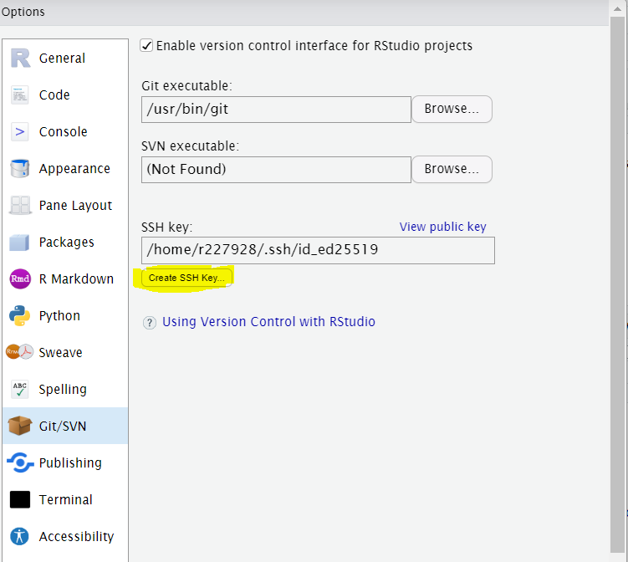

1. Add the public key to your Github account:

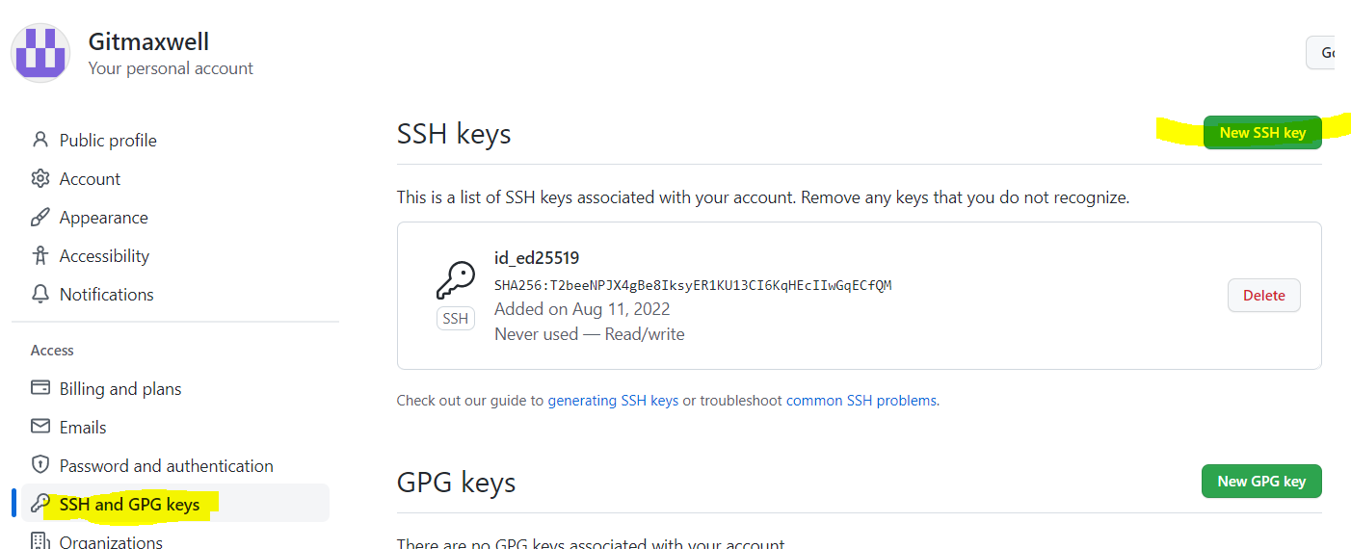

1. In terminal push to git:

git push -u origin master

1. Use commit as normal in Git tab in RStudio:
2. 